

1ST HOMEWORK

DATA STRUCTURES AND LABORATORY



October 4, 2015

TUĞBA ÖZKAL

150120053

**P:** Prints all the records which exists in the catalogue.

**A:** Searches the records by author. (In this command, the user must enter the author after the program asks the name of the author then the program should print the records that belongs to the related author.)

**T:** Searches the records by type. (In this command, the user must enter the type of the book after the program asks the type then the program should print the records whose type is the given type by the user.)

**I:** Inserts the record which is entered by the user.

**R:** Removes the record which is entered by the user. (In this command, the user must enter the ISBN of the book after the program asks the ISBN then the program should delete the record whose ISBN is given by the user.)

**U:** Updates the record which is entered by the user. (In this command, the user must enter the ISBN of the book after the program asks the ISBN then the program should update the record whose ISBN is given by the user.)

**E:** Exists the program.

# How do you do your homework?

I use many sources I was doing my homework. As books;

* C How to Program (Deitel & Deitel)
* Veri Yapıları ve Algoritmaları (Rıfat Çölkesen)

As presentations;

* Data Structures and Laboratory (BLG 233E) lecture presentations

I have looked code examples. Those are,

* Code examples in Ninova,
* My homework which I did when I took this lesson in last semester,
* My codes which I wrote in laboratory.

# Which data structure you use?

I used ‘struct’ type.

# Why you use this data structures?

We need structs to keep information of books. And the other reason is that we haven’t seen other types (linked list, stack, queue etc.) yet. For now, it is enough to write this program.

# Which part of your code does the function of each command given above?

All file operation functions those are given above are declared in ‘operations.h’. All of them are described in ‘operations.cpp’. Other functions those for program operations, are in ‘Source.cpp’.

//operations.h

struct File{

char* filename;

FILE* bookregistry;

void create();

void close();

void insert(Book_Record*); //add a new book registry

int searchAuthor(char[], char[]); //user must enter the name of author

int searchTitle(char[]); //user must enter the name of book

void update(long long int, Book_Record*); //user must enter isbn

void remove(long long int); //user must enter isbn

void print(); //print all books with their authors

int searchISBN(long long int); //here books are checked by ISBN, this //function is written to use in other functions.

int searchLocation(int); //here books are checked by location, //this function is written to use in other functions.

};

# The screenshot of the console of your program.

1. 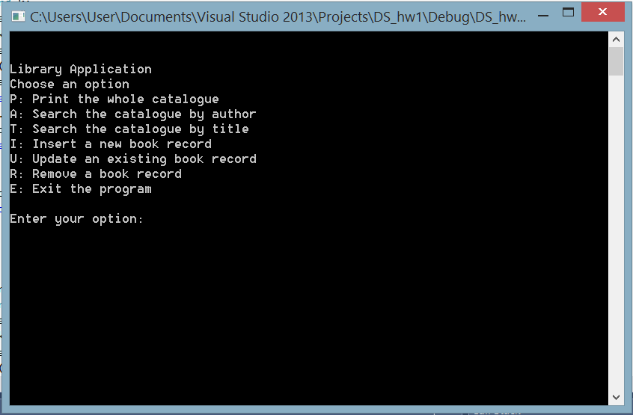MS Visual Studio;
2. Linux SSH;